**Questions**

**Name:**

**Year 10 Foundation – Test 3 – February 2024**

**Calculators May Be Used – 50 marks available**

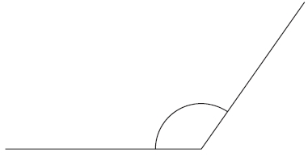

**Q1.** Here is an angle

(i)  What type of angle is it? ...........................................................

(ii)  Measure the size of the angle.

...........................................................°

**(Total for question = 2 marks)**

**Q2.**

The diagram shows the position of town *T*.



Town *R* is 55 km from town *T* on a bearing of 065°

Mark the position of town *R* with a cross (×).

Use a scale of 1 cm to 10 km.

**(Total for question = 2 marks)**

**Q3.** The diagram shows a shape on a centimetre grid.

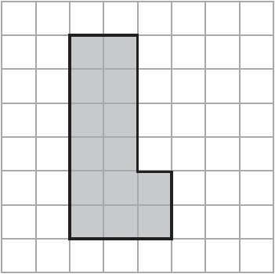

(a)  Find the area of the shape.

........................................................... cm2

**(1)**

(b)  Find the perimeter of the shape.

........................................................... cm

**(1)**

**(Total for question = 2 marks)**

**Q4.** Here is a shape made from a rectangle and a triangle.

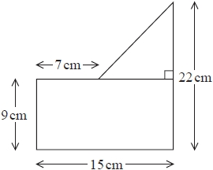

Work out the total area of the shape.

........................................................... cm2

**(Total for question = 3 marks)**

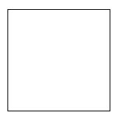 **Q5.**Here is a square.

(a) On the square, draw all the lines of symmetry.

**(2)**

   Here is a rectangle.

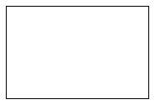

(b) Write down the order of rotational symmetry of the rectangle.

      ..............................................................................................................................................

**(1)**

Here is a different rectangle.

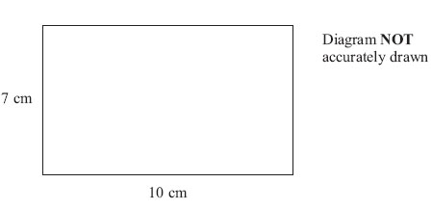

(c) Work out the area of this rectangle.

. . . . . . . . . . . . . . . . . . . . . . cm2

**(2)**

**(Total for Question = 5 marks)**

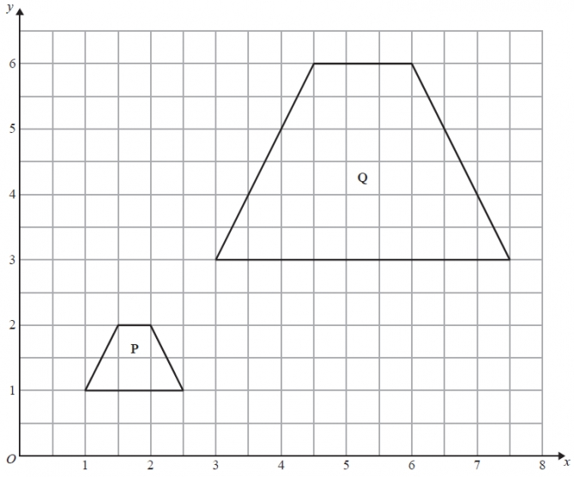

**Q6.**

Describe fully the single transformation that maps shape **P** onto shape **Q**.

.............................................................................................................................................

.............................................................................................................................................

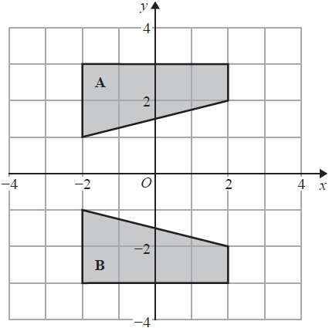  
**(Total for Question = 3 marks)**

**Q7.**

Describe fully the single transformation that maps shape **A** onto shape **B**.

.............................................................................................................................................

**(Total for question = 2 marks)**

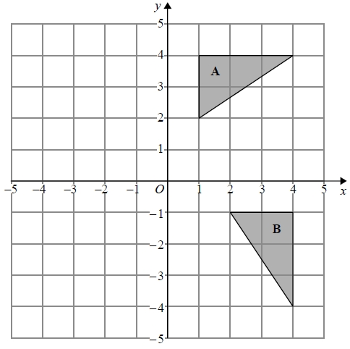

**Q8.**

Describe fully the single transformation that maps triangle **A** onto triangle **B**.

.............................................................................................................................................

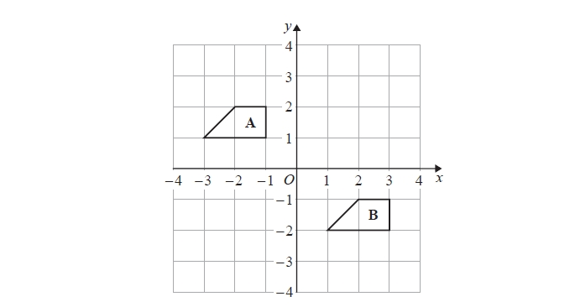 .............................................................................................................................................

**(Total for question = 2 marks)**

**Q9.**

Describe the single transformation that maps shape **A** onto shape **B**.

.............................................................................................................................................

.............................................................................................................................................

**(Total for question = 2 marks)**

**Q10.**

Here are two squares.

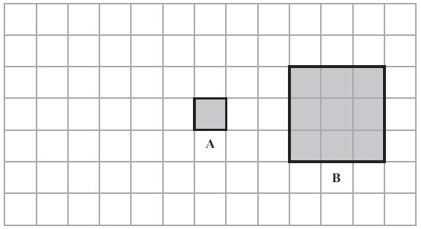

Square **B** is an enlargement of square **A**.

(a) What is the scale factor of the enlargement?

      ..............................................................................................................................................

**(1)**

Square **A** is moved 4 squares to the left.

(b) On the grid, draw the new position of square **A**.

**(1)**

(c) In the space below, draw accurately a square with side of length 4 cm.

**(2)**

**(Total for Question = 4 marks)**

**Q11.** Shari has a fair ordinary dice. She rolls the dice once.

(a)  On the probability scale, mark with a cross (×) the probability that Shari gets the number 7



**(1)**

(b)  On the probability scale, mark with a cross (×) the probability that Shari gets an even number.

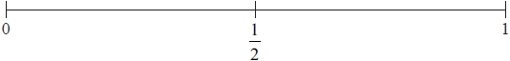

**(1)**

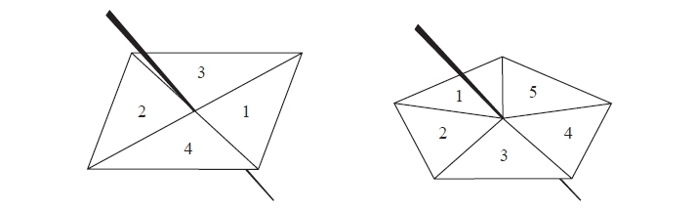 **(Total for question = 2 marks)**

**Q12.** Here are a 4–sided spinner and a 5–sided spinner.

The spinners are fair.

Jeff is going to spin each spinner once.   
Each spinner will land on a number.   
Jeff will get his score by adding these two numbers together.

(a)  Complete the possibility space diagram for each possible score.

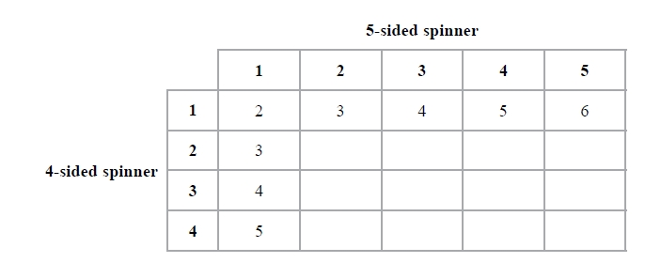

**(1)**

Jeff spins each spinner once.

(b)  Find the probability that Jeff gets

(i)  a score of 3

...........................................................

(ii)  a score of 5 or more.

...........................................................

**(2)**

**(Total for question = 3 marks)**

**Q13.**

Sue has a bag of 18 sweets.

5 of the sweets are blue  
7 of the sweets are red  
6 of the sweets are green

Sue takes at random a sweet from the bag.

Write down the probability that Sue

(i) takes a red sweet,

      ..............................................................................................................................................

(ii) does **not** take a green sweet,

      ..............................................................................................................................................

(iii) takes a yellow sweet.

      ..............................................................................................................................................

**(Total for Question = 3 marks)**

**Q14.** Write 478 to the nearest hundred.

...........................................................

**(Total for question = 1 mark)**

**Q15.** (a)  Write 2530 correct to 2 significant figures.

...........................................................

**(1)**

(b)  Write 0.0874 correct to 1 significant figure.

...........................................................

**(1)**

**(Total for question = 2 marks)**

**Q16.**

(a)  Write 7357 correct to 3 significant figures.

...........................................................

**(1)**



Write down all the figures on your calculator display.

...........................................................

**(2)**

**(Total for question = 3 marks)**

**Q17.** Emily drives 186 miles in 3 hours.

(a)  What is her average speed?

........................................................... mph

**(2)**

Sarah drives at an average speed of 58 mph for 4 hours.

(b)  How many miles does Sarah drive?

........................................................... miles

**(2)**

**(Total for question = 4 marks)**

**Q18.** Change 53 centimetres to millimetres.

........................................................... millimetres

**(Total for question = 1 mark)**

**Q19.** Polly has a full 5 kg sack of rice.

She pours the rice from this sack into bags.   
She fills as many bags as possible.

Each full bag contains 350 g of rice.

(a)  How many bags did Polly fill from this sack of rice?

...........................................................

**(3)**

Polly assumes that the rice from two sacks will fill twice as many bags as the rice from one sack.

(b)  Is Polly correct?

You must give a reason for your answer.  
  
  
 .............................................................................................................................................

.............................................................................................................................................

**(1)**

**(Total for question = 4 marks)**